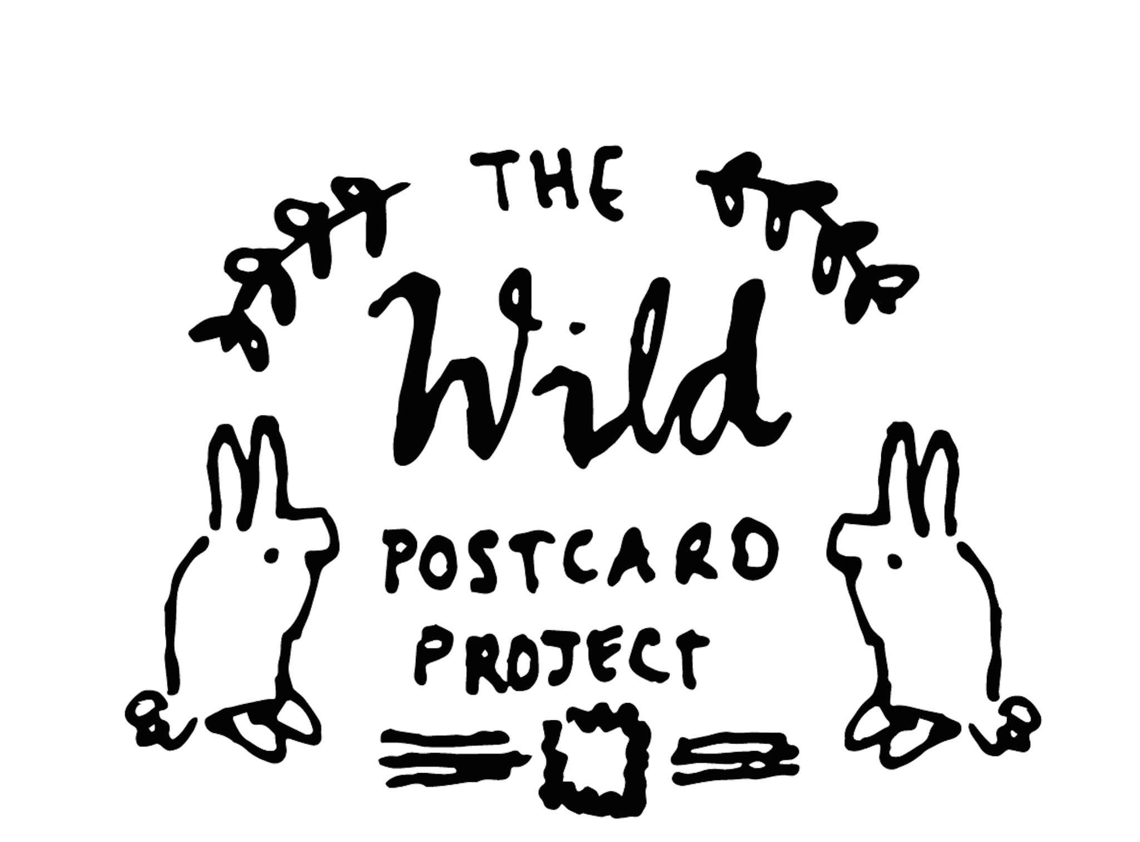
SCHOOL/GROUP ENTRY FORM

Note:
- Please include one entry form per class.
- Have your students write their names on their artwork so we can identify each piece

Contact details (must be completed by teacher or tutor):

School name:_____________________________________________________________

Teacher name:____________________________________________________________

E-mail:__________________________________________________________________

Phone: _________________________________________________________________

Address:________________________________________________________________

Country:________________________________________________________________

Are you in a: (you can select more than one!)

▭ Coastal area ▭ Mountain region ▭ Desert/Arid Region
▭ Forest/Jungle Region ▭ Highland/Plateau Region ▭ Cityscape

Where did you hear about this competition? (you can select more than one!)

▭ School ▭ Family ▭ Instagram ▭ Facebook
▭ Other social media ▭ Poster / leaflet ▭ E-mail

Protecting biodiversity is important to us, and so are your personal details! Researchers would like to borrow the information you provided in this entry form (including these artwork) to see how they can improve biodiversity conservation globally. Please select one of the following:

▭ Yes, I'm ok with you sharing my anonymized information with researchers
▭ No, I would prefer you not share my anonymized information with researchers

I grant permission to the Wild Postcard Project to use this artwork in various forms, this may include postcards, billboards, social media, etc.

▭ YES ▭ NO

Please submit your entries by email: wildpostcardproject@gmail.com
OR post: Wild Postcard Project, 7 O'Donovan Road, Dublin 8, D08 V56E, IRELAND

An answer should be provided for each student:

Note: Complete this section only if a pre-prepared Wild Postcard Project activity sheet was not used by your students.

Name of student | Age | Title of artwork | Short description of your artwork | What's your favourite biodiversity?
Name of student | Age | Title of artwork | Short description of your artwork | What's your favourite biodiversity?

